Arduino MKR 1010

<https://www.youtube.com/watch?v=yG-9fzXvPDg>

IoT <https://github.com/arduino/iot-client-py#authentication>

MQTT <https://www.youtube.com/watch?v=LSrDIklFiJ8>

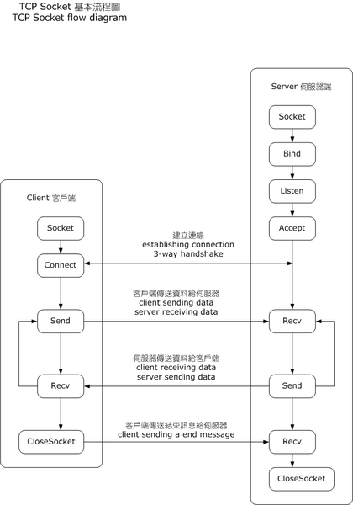

<https://commons.wikimedia.org/wiki/File:InternetSocketBasicDiagram_zhtw.png>